**Session 1 Assignment2:**

Explain below linux commands with an example:

1. **pwd**

* pwd is “present working directory”
* pwd linux command prints the name of the current working directory
* pwd prints the full pathname of the current working directory

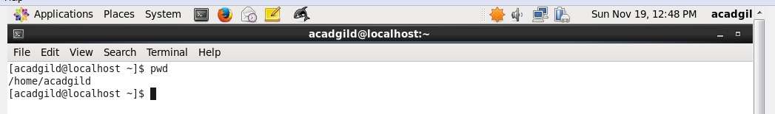

1. **vi:**

* vi is a visual text editor used to edit the file….

Using **vi** command file can be opened as shown below:



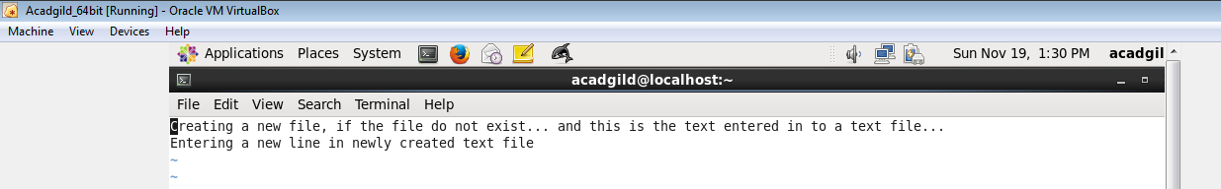

Editing a text file that already exists:

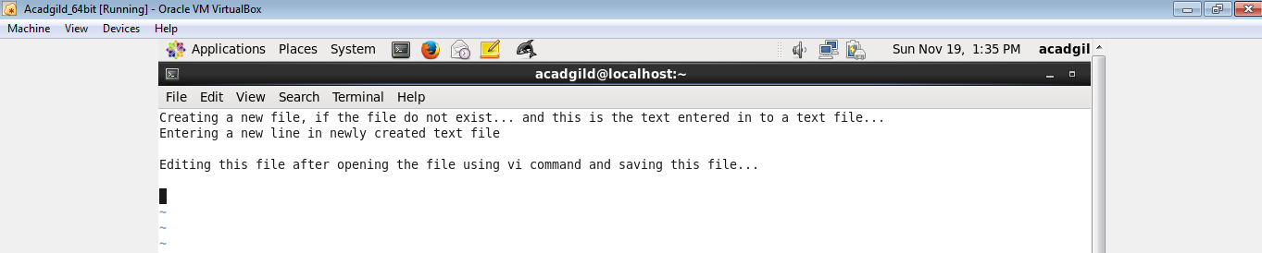

Saving the edited text inside “Firstfile.txt”

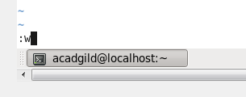

Again open the file using vi command to ensure recent typed text is saved in a file:

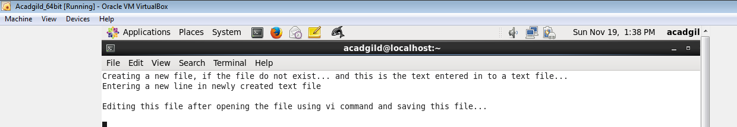

1. **touch:**

* touch linux command changes file timestamps
* touch linux command updates the access and modification times of each FILE to the current system time

Example: touch file.txt ------- If file.txt exists, touch updates its access and modification times to the current time, and if file.txt does not exist then a new empty file will be created.

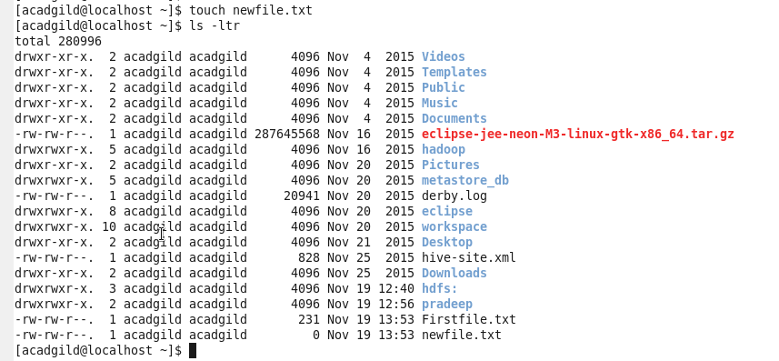

Now again typing **touch** command to modify creation time of a file:

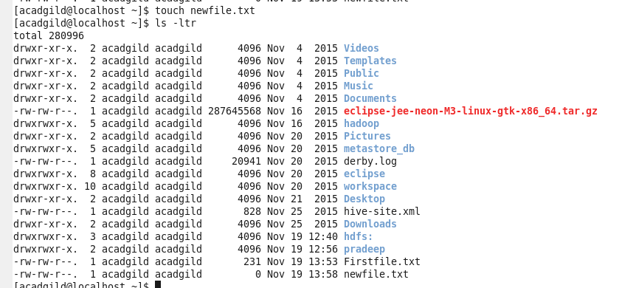

1. **mkdir:**

* mkdir is kown as “make directory”, mkdir is used to create directories on a file system
* if the specified directory doesnot already exist, mkdir creates it.

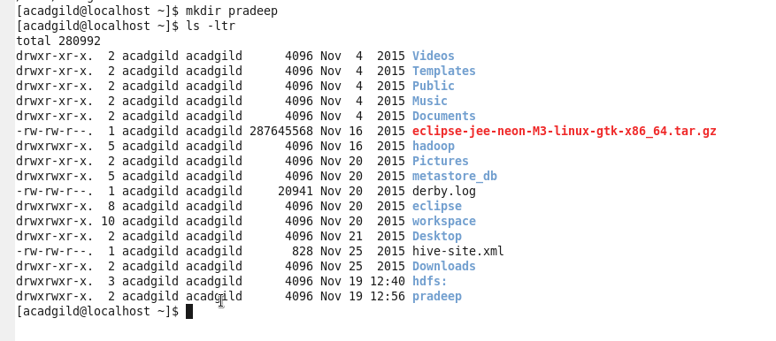

1. **rm:**

* **rm** linux command removes or deletes files / directories
* **rm** command removes each specified FILE
* removal process unlinks a filename in a file system from data on the storage device

Removing file “newfile.txt” using **rm** command

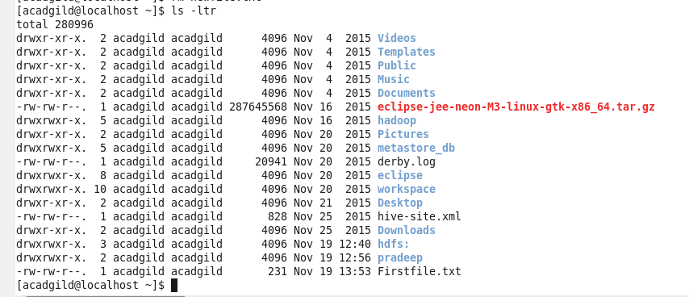

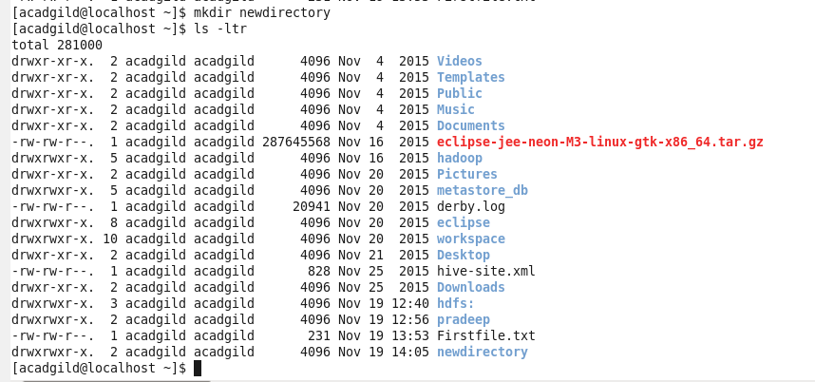



Directory is removed using **rm** command:

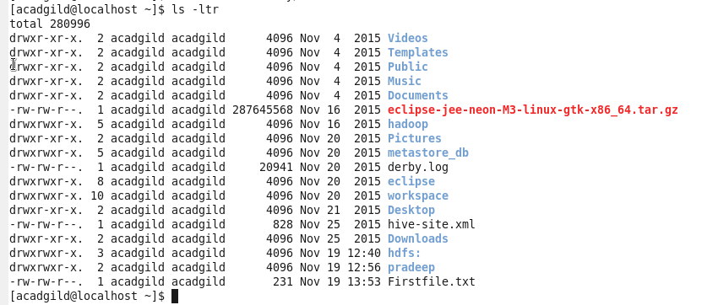

1. **ls:**

* **ls** is the linux command used to list the contents of a directory
* this command lists the information about the files that are in current directory and also sort entries alphabetically if nothing specified

**ls-l:** this command lists the total files in the directory and subdirectories, names of the files in current directory, their permissions, file size and last modification date.

**ls-ltr:** list files sorted by the time they were last modified – most recently modified files will be last.

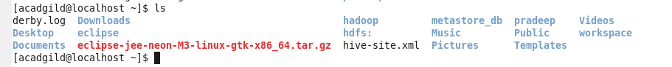

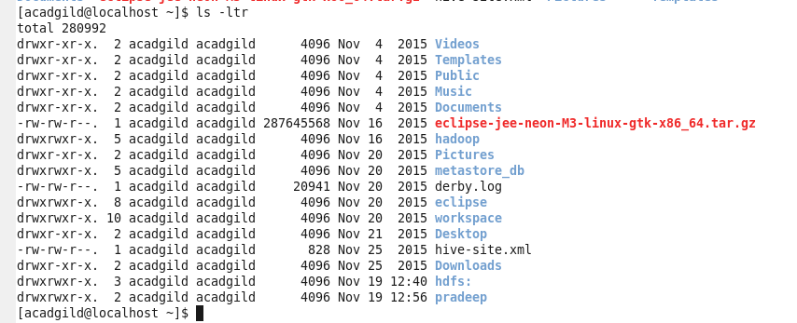

1. **echo:**

* echo linux command displays a line of text

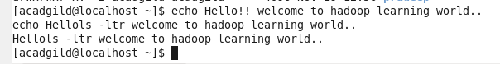



**New file is created in current working directory:**

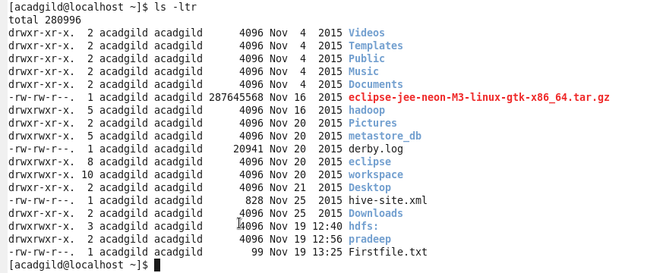

Entering another line in created file:



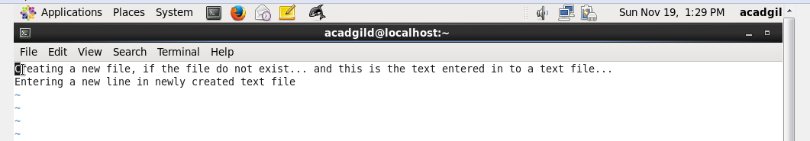

1. **cat:**

* cat stands for ‘catenate’
* cat command reads the data from files and output their comments
* cat command is used to:
  + display text files
  + copy text files in to a new document
  + append the contents of a text file to the end of another text file, combining them.

Cat command displays contents of a file:

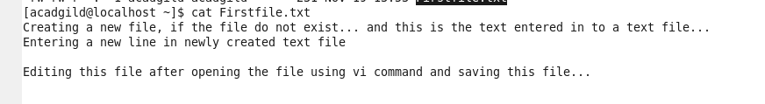

Using cat command, contents of one file can be copied in to another file:



Second file is created:

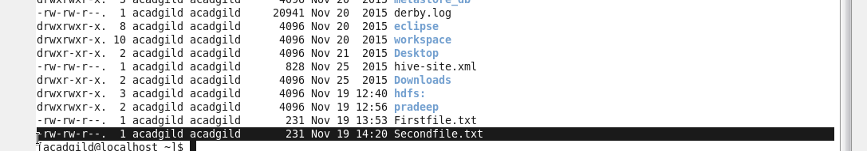

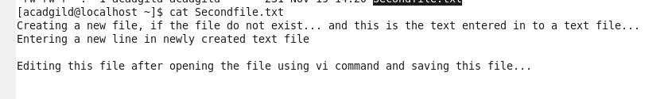

1. **who**

* **who** command displays who is logged on to the system
* who command prints the information about all users who are currently logged in…
* who command displays the username, line and time of all currently logged in sessions.

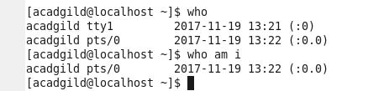

1. **cd**

* **cd** linux command is used to move around within the hierarchy of filesystem
* cd stands for “change directory” --- changes the shell’s current working directory

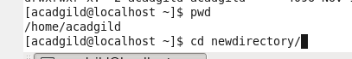

**cd..** command is used to represent parent directory:

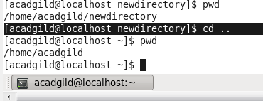

**Cd~**  is used to represent home directory

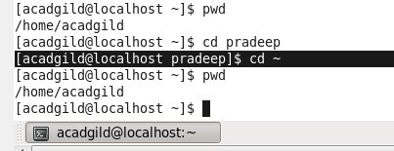

**Cd /** is used to represent root directory:

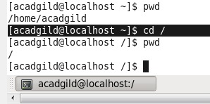

1. **date:**

* date command is used to print out or change the value of system’s time and date information



1. **cal:**

* **cal** displays a conveniently – formatted calendar from the command lime…

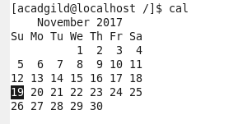

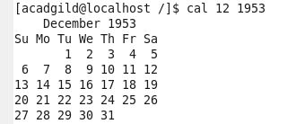

1. **mv:**

* mv linux command is used to move or rename files / directories.

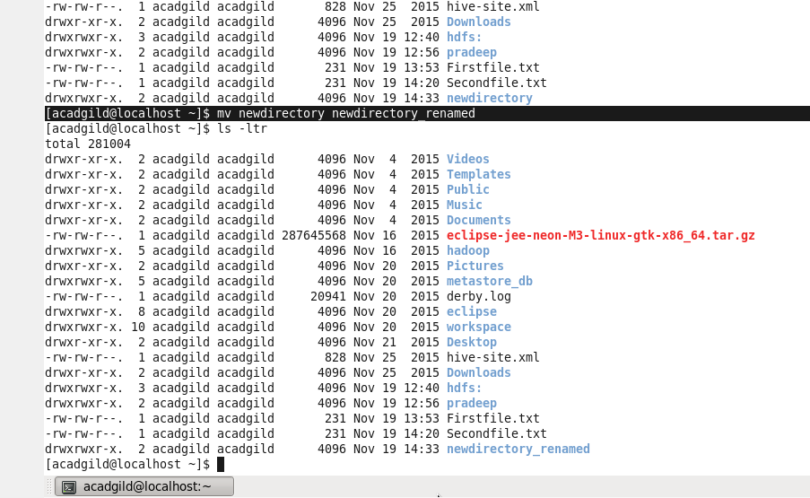

Moving file in to another directory:





1. **cp:**

cp linux command is used to make copies of files and directories

original file in a directory:

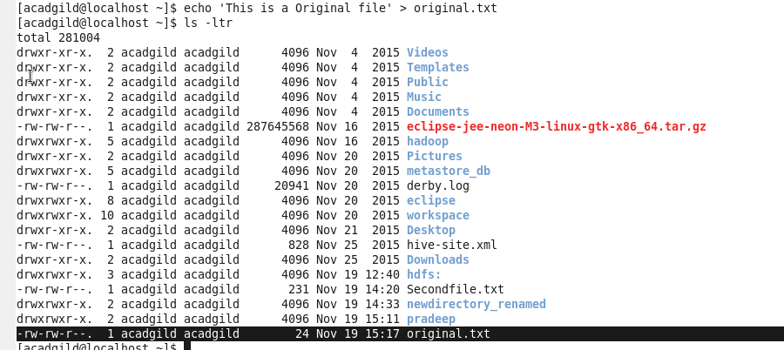

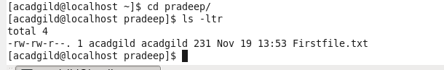

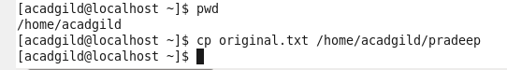

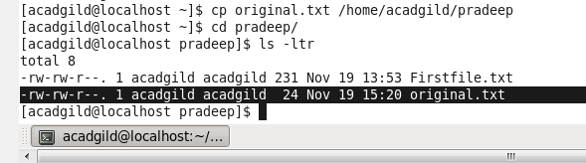

1. **which:**

* which command locate the executable file associated with a given command
* which command returns the pathnames of the files which would be executed in current environment



